**Coding**

**Calculate.php**

<?php

include "include/nav.php";

?>

<!DOCTYPE html>

<html lang="en">

<head>

<meta charset="utf-8">

<meta name="viewport" content="width=device-width, initial-scale=1, shrink-to-fit=no">

<<meta name="viewport" contecnt="width=device-width, initial-scale=1.0">

<meta http-equiv="X-UA-Compatible" content="ie=edge">

<!--Bottstrap-->

<link rel="stylesheet" href="css/bootstrap.min.css">

<title>Assigment 2</title>

<!-- Bootstrap core CSS -->

<link href="vendor/bootstrap/css/bootstrap.min.css" rel="stylesheet">

<!-- Custom styles for this template -->

<link href="css/shop-homepage.css" rel="stylesheet">

</head>

<body>

<form action="process/function.php" method="post">

<!-- Page Content -->

<div class="container">

<div class="row">

</div>

<div class="row">

<!-- Small Pizza -->

<div class="col-lg-4 col-md-6 mb-4">

<div class="card h-100">

<div class="card-body">

<h4 class="card-title">

<label> Pizza Small 9 Inch</label>

</h4>

<h5>RM10.00</h5>

<br>

<input type="radio" name="pizza" value="small"> Select

<br>

<br>

<!-- Sauces -->

<label>Sauces</label>

<br>

<input type="radio" name="sauces" value="royalcheese"> Royal Cheese

<br>

<input type="radio" name="sauces" value="spicyasian"> Spicy Asian

<br>

<input type="radio" name="sauces" value="bbq"> BBQ

<br>

<br>

<!-- Topping -->

<label>Toping</label>

<br>

<input type="checkbox" name="topping[]" value="prawn">Prawn<br>

<input type="checkbox" name="topping[]" value="chicken">Chicken<br>

<input type="checkbox" name="topping[]" value="beef">Beef<br>

<p class="card-text"></p>

</div>

</div>

</div>

<!-- Medium Pizza -->

<div class="col-lg-4 col-md-6 mb-4">

<div class="card h-100">

<div class="card-body">

<h4 class="card-title">

<label> Pizza Medium 9 Inch</label>

</h4>

<h5>RM20.50</h5>

<br>

<input type="radio" name="pizza" value="medium"> Select

<br>

<br>

<!-- Sauces -->

<label>Sauces</label>

<br>

<input type="radio" name="sauces" value="royalcheese"> Royal Cheese

<br>

<input type="radio" name="sauces" value="spicyasian"> Spicy Asian

<br>

<input type="radio" name="sauces" value="bbq"> BBQ

<br>

<br>

<!-- Topping -->

<label>Topping</label>

<br>

<input type="checkbox" name="topping[]" value="prawn">Prawn<br>

<input type="checkbox" name="topping[]" value="chicken">Chicken<br>

<input type="checkbox" name="topping[]" value="beef">Beef<br>

<p class="card-text"></p>

</div>

</div>

</div>

<!-- Large Pizza -->

<div class="col-lg-4 col-md-6 mb-4">

<div class="card h-100">

<div class="card-body">

<h4 class="card-title">

<label> Pizza Large 12 Inch</label>

</h4>

<h5>RM30.00</h5>

<br>

<input type="radio" name="pizza" value="large"> Select

<br>

<br>

<!-- Sauces -->

<label>Sauces</label>

<br>

<input type="radio" name="sauces" value="royalcheese"> Royal Cheese

<br>

<input type="radio" name="sauces" value="spicyasian"> Spicy Asian

<br>

<input type="radio" name="sauces" value="bbq"> BBQ

<br>

<br>

<!-- Topping -->

<label>Topping</label>

<br>

<input type="checkbox" name="topping[]" value="prawn">Prawn<br>

<input type="checkbox" name="topping[]" value="chicken">Chicken<br>

<input type="checkbox" name="topping[]" value="beef">Beef<br>

<p class="card-text"></p>

</div>

</div>

</div>

</div>

<!--Button-->

<div class="text-center">

<button type="submit" name='option' value="" class="btn btn-primary" >Submit Oder</button>

<button type="reset" name='option' value="" class="btn btn-danger" >Reset</button>

</div>

<br>

</form>

<!-- Bootstrap core JavaScript -->

<script src="vendor/jquery/jquery.min.js"></script>

<script src="vendor/bootstrap/js/bootstrap.bundle.min.js"></script>

</body>

</html>

**Function.php**

<?php

$pizza = $_POST['pizza'];

$sauce = $_POST['sauces'];

$topping = $_POST['topping'];

$total = 0;

$pizzasize = '';

$csauces = '';

//pizza

switch ($pizza)

{

case 'small':

$pizzasize = 'Small 6 inch';

$total = $total + 10;

break;

case 'medium':

$pizzasize = 'Small 9 inch';

$total = $total + 20.50;

break;

case 'large':

$pizzasize = 'Large 12 inch';

$total = $total + 30.00;

break;

}

//topping more than 1

for($i = 0; $i < count ($topping); $i++)

{

switch ($topping[$i])

{

case 'prawn':

$total = $total + 5.00;

break;

case 'chicken':

$total = $total + 5.00;

break;

case 'beef':

$total = $total + 8.00;

break;

}

}

// sauces

switch ($sauce)

{

case 'royalcheese':

$csauces = 'Royal Cheese';

break;

case 'spicyasian':

$csauces = 'Spicy Asian';

break;

case 'bbq':

$csauces = 'BBQ';

break;

}

//print all

echo 'Pizza Size = '.$pizzasize;

echo '<br>';

echo 'Sauces = '.$csauces;

echo '<br>';

echo 'Topping = '.implode(" + ",$topping);

echo '<br>';

echo 'Total = '. $total;

?>

**nav.php**

<!-- Navigation -->

<nav class="navbar navbar-expand-lg navbar-dark bg-dark fixed-top">

<div class="container">

<a class="navbar-brand" href="#">AHMAD KHALIS AFFANDI BIN AHMAD KHALIS (AM1801003416)</a>

</div>

</nav>

<br>

**ScreenShot**

1.Select Item that you want and click submit oder

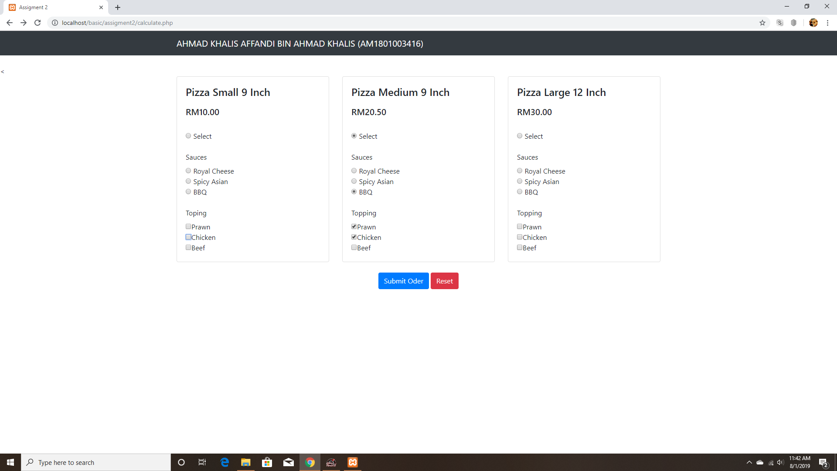

2.Result

